ONLINE BOOK SHOPPING   APPLICATION

**OVERVIEW**

We will try to make online  book shopping application  with the help of node js and express.

**WORKING**

In this application we will have five  section , the first section will be home  page ,second section will be  the login page ,  third section will be products page ,fourth section will be payment page

In the home page section it will have navbar from where he can perform many task, he can create new user, he can directly log in , he can go to about page and various activities,

In case the user didn't have facebook or google account , then we have provided the option of custom login , In this user first has to sign up , he will give his\her info, from there we will set his account and we will provide username and password via email. And from this detail  he/she can log in.

In the login page section we will try to login the user by various method like he/she can log in with the help of google,facebook and custom login with the help of username and password. In this we will use passport google oauth package.

In the product page or product page there will  be books which he/she  can buy and after clicking on the payment button he will be redirected to the  payment gateway. In this i have added paytm gateway.

In the fourth  page there will be the payment gateway in which the user will fill in their card details , this page will also have authentication , and once all the details are complete it will be redirected to the success page .

There will also be admin login from homepage , only admin can log in from this page , admin can modify the content from product page , admin can perform crud operation in product page . But in this project we didn't provide the ui for admin , all the operations are performed with the help of a tool which is postman

**BLOCK DIAGRAM**

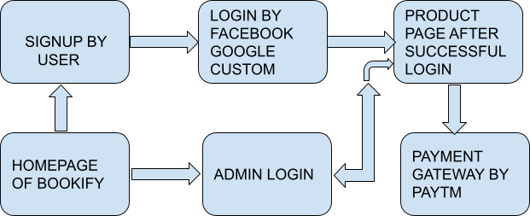

**TECHNOLOGY AND PACKAGES USED:**

**1.**Node js

**2.**Express

**3.**Passport Authentication

**4.**Paytm Gateway

**5.**Mongoose

**6.**Tempelate Engines/Bootstrap

**7. .**Env

**8.**Body-Parser

**9.** Cookies/Session

For deployment we will use heroku .

**FUTURE MODIFICATION:**

In future for the login page we will try to give more options for log in like he/she can do the login with the help of google , facebook,linkedin and in product page also we will be adding chat facilities for customers for any support.

Right now admin work has been done only in api. We didn't provide the ui for the admin side.

On the payment side we will  try to give more options for payment like stripe and paypal , phone pe etc.

We will also add more and more items ,we will convert this book shopping into a complete E- shopping cart .